Side Approach Details

**Simulation Work**

World Coordinate System (Right-Hand-Rule): +Z:Up, +Y: Left, +X:Forward

Homing Hand Position: <0.3324, -0.1722, 0.33692>

**Directions of Motions:**

* Remember that we are moving in the negative direction of the gradient error, such that:
$$Error= -Error=-(Des-Actual)$$

* If the desired force is <-1,0,0> and the actual force is <0,0,0> we have:
$$Error= -\left(-1-0\right)= 1$$

* For the simulation base2hand rotation we have a matrix:
$$R_{b}^{h}=\left[\begin{matrix}0 & 0 & -1 \\ 0 & 1 & 0 \\ 1 & 0 & 0\end{matrix}\right]$$

* The transformation looks like:

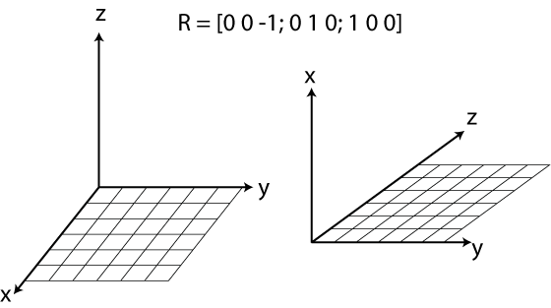

* All desired commands are given in world coordinates but effected in local coordinates. So <1,0,0> becomes <0,0,1>.

**Motions about the different axis:**

Describing the motion of the manipulator when a certain desired force/moment is given in one direction and for actual forces/moments of <0,0,0>

Fx > 0, motion down. Fy > 0, motion left. Fz > 0, motion fwd  
Fx < 0, motion up. Fy < 0, motion right Fz < 0, motion bwd

Mx > 0, yaw CCW. My > 0, Pitch over n down. Mz > 0, Roll CW  
Mx < 0, yaw CW.. My < 0, Pitch under and up Mz < 0, Roll CCW

**Notes:**

* In between cycles, the arm moves due to the gravitational effect. The joint PD controller reads actual angles that have been slightly influenced by gravity.
* I still don’t get pure motions from the Jacobian in some directions.